Learning Styles
Instruction for Online Tests

How do you think? How do you best read? How should you study and learn?
These websites will help you determine and maximize your strengths and overcome your weaknesses!

1. Click on each blue web link citation below on this page.
2. Take the 4 learning styles tests.
3. Read about your strengths and weaknesses and how to improve how you read/study.
4. Record your results on your printed page 2.
5. Write at least 2 things that you learned about how you can improve how you read/study.
6. Turn in page 2 to me by Tuesday. (Remember extra credit for turning in assignments early! ☺ )
(Although some of the sites ask your name and other personal information you do NOT have to give them!)

Your learning style:
visual or auditory or kinesthetic
individual or group
written or verbal
http://www.vark-learn.com/english/page.asp?p=questionnaire
http://www.engr.ncsu.edu/learningstyles/ilsweb.html

Your personal thinking style :
concrete or abstract
sequential or random

http://www.thelearningweb.net/personalthink.html

http://www.floatingneutrinos.com/Message/arcs/links_on_abstractrandom.htm

(explanation of test results for The Learning Web)

What intelligence areas are your strengths:
1. Verbal/Linguistic
2. Logical/Mathematical
3. Visual/spatial
4. Bodily/Kinesthetic
5. Musical
6. Interpersonal
7. Intrapersonal
8. Naturalist

http://www.literacyworks.org/mi/assessment/findyourstrengths.html
Remember, do NOT give out your personal information just because a site requests it!!

Learning test | Results | Besides my scores, at least 2 things that I learned about how I should read/study
VARK | Score areas and #’s
ILSQ | Preference and score or each scale.  1.  2.  3.  4.
Personal Thinking | CS  AS  AR  CR
Literacy Works | Lang (verb/ling)  Logic/Math  Spacial (vis)  BodMov/Kin  Musical  Social (interp)  Self (intrap)  Natural

VARK: Respond to the statements and submit them for scoring.

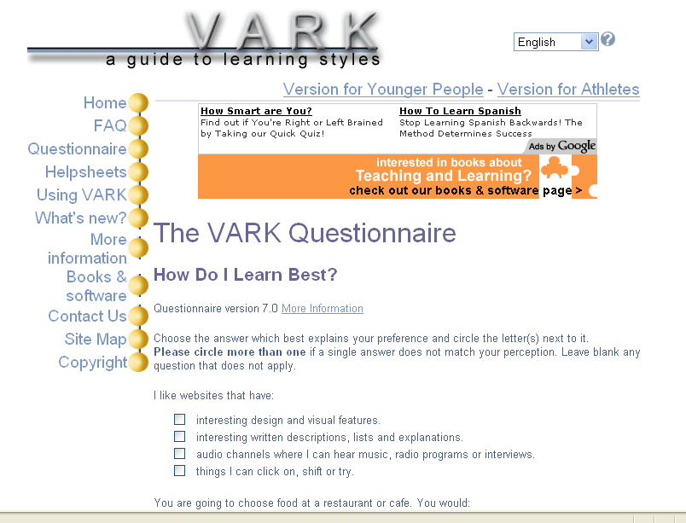

Read your score and general information about your learning preferences.
Then click on the link to read more detailed information.

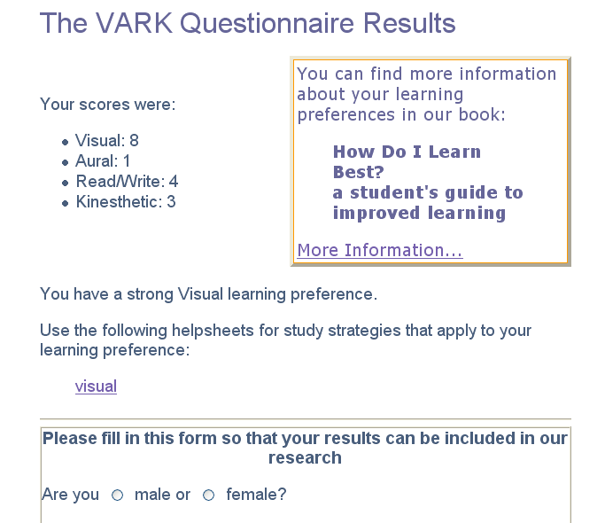

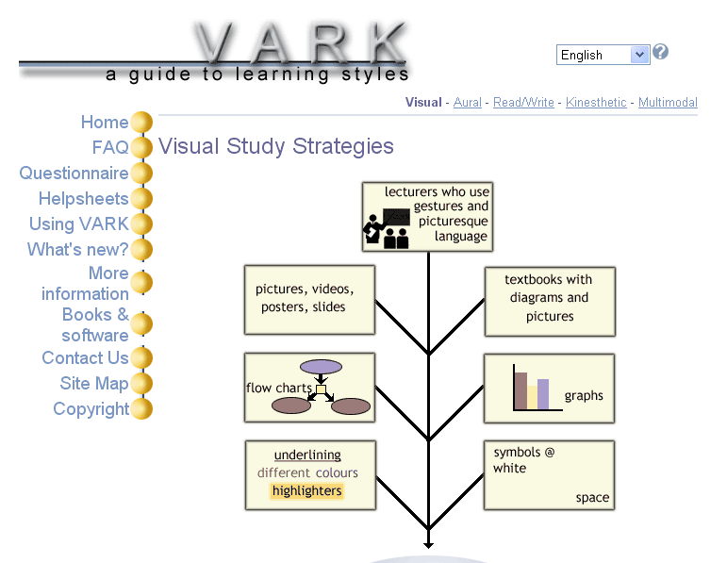

ILSQ: Respond to the statements and submit them for scoring.

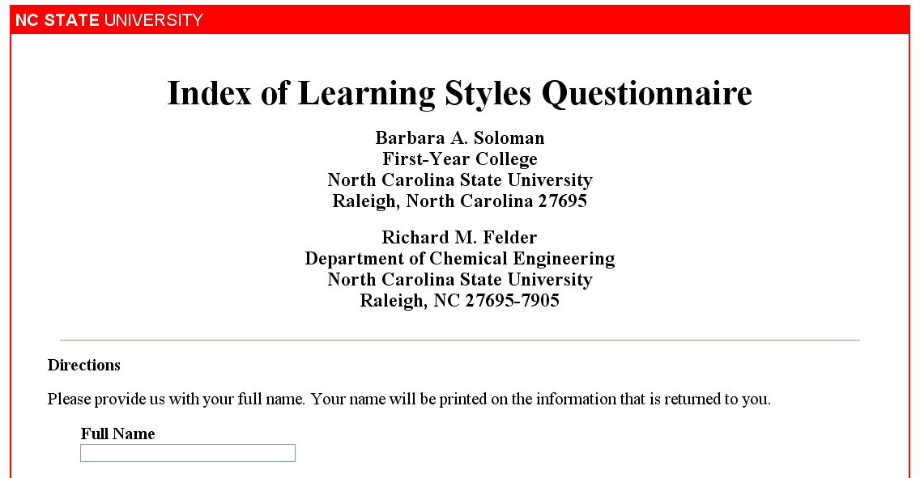

Read your score (the X above a number indicates toward which style you tend) and general information about your learning preferences.
Then click on the link to read more detailed information.

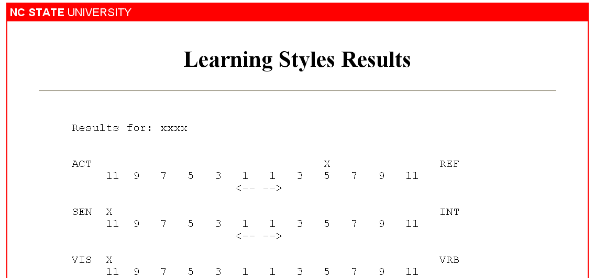
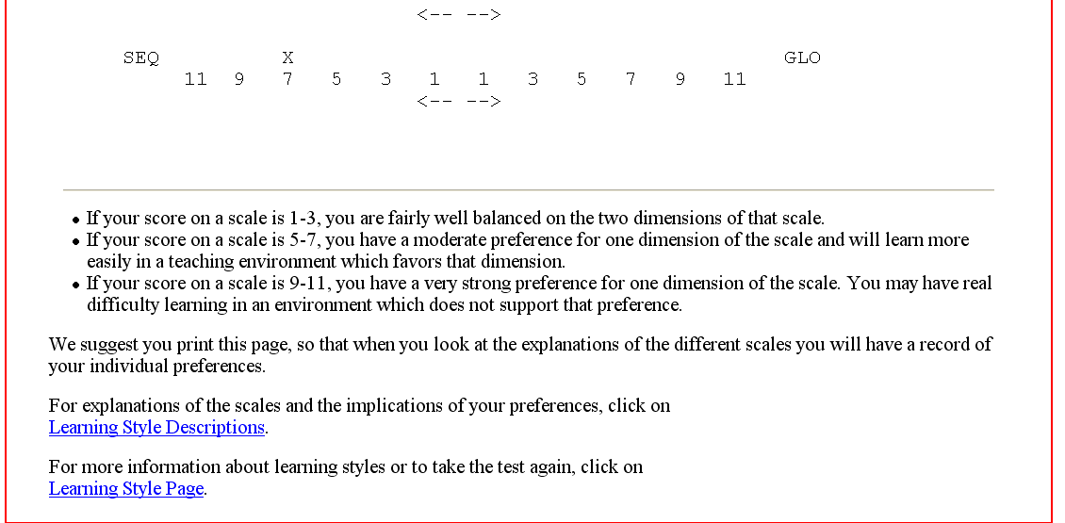
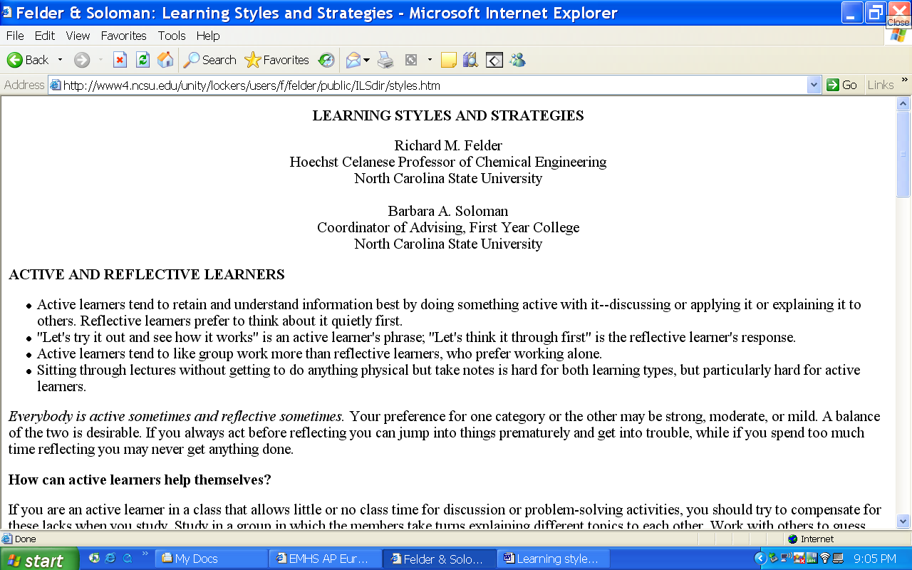

Personal Thinking Styles: Print out a copy of the test and choose the 2 words that best describe you from each set of words. Do the math to create your final scores and graph them on the chart.
Then click on the next link on our website to read about what your graph says about you and what you can do to improve your areas of weakness.

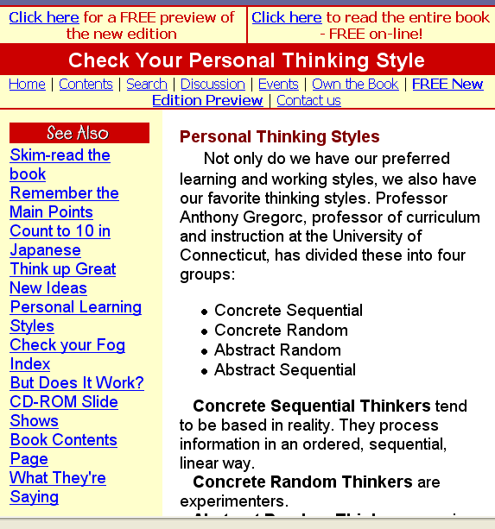

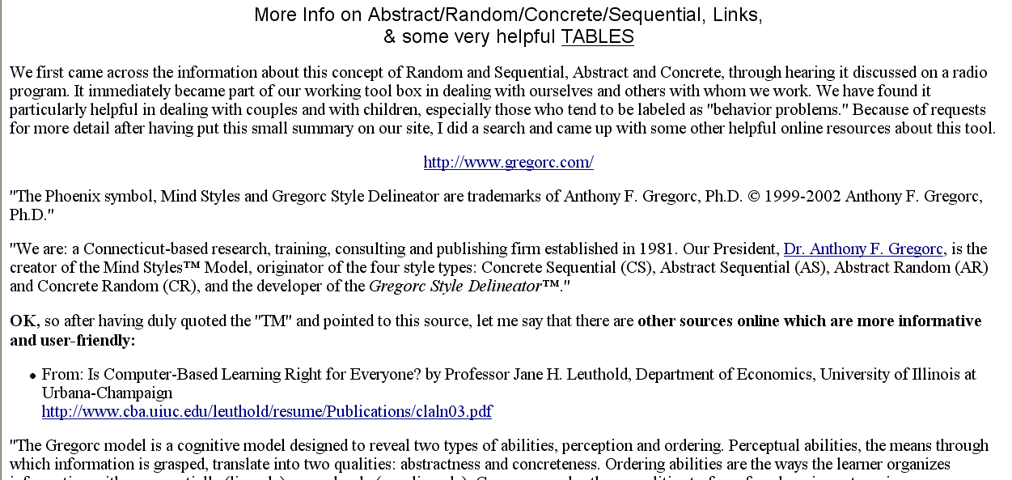

LDRC: Respond to the statements and submit them for scoring. Remember that you don’t have to give your real name; you can make one up.

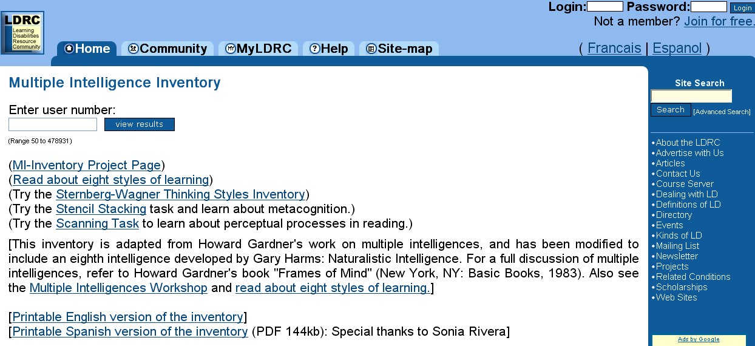
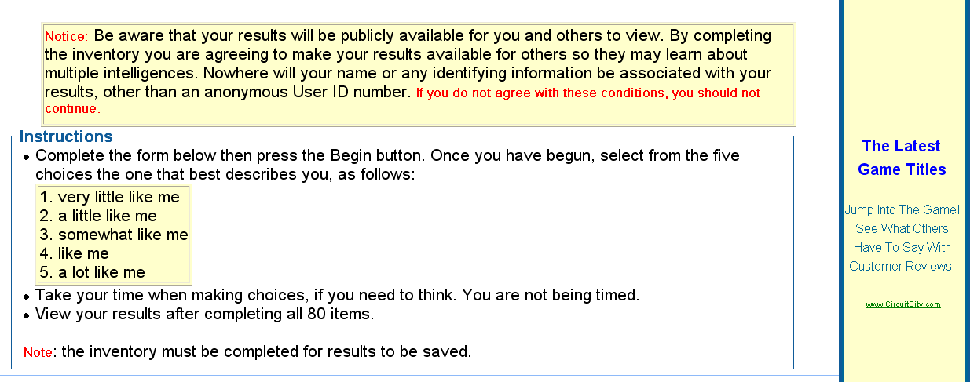
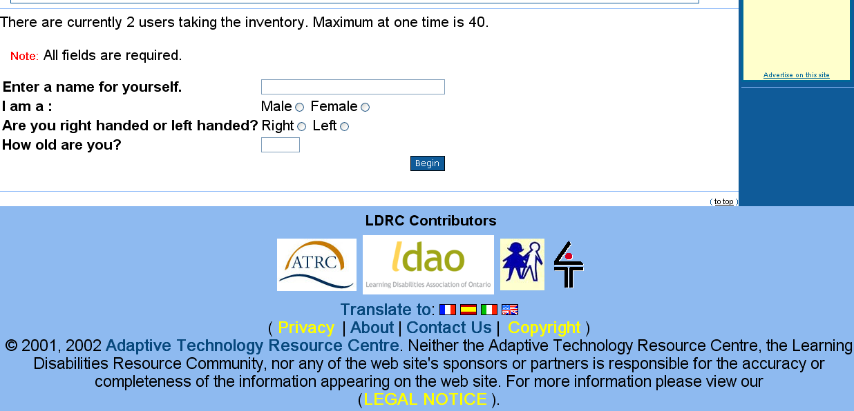
Read your score.
Then click on the link to read more detailed information.

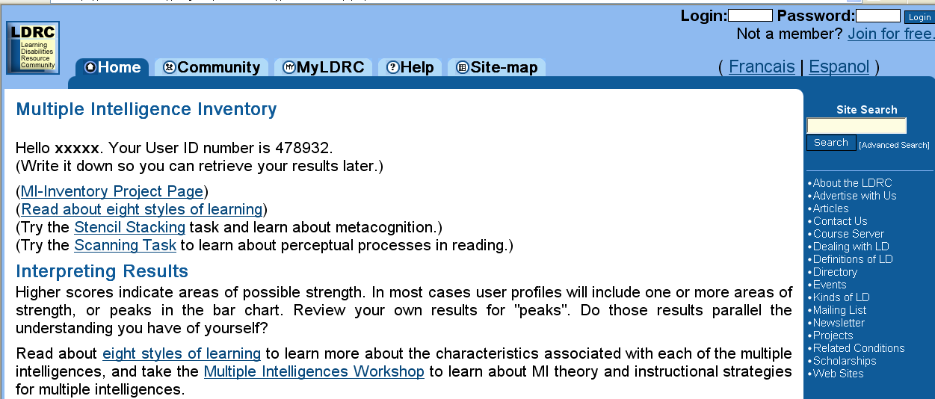
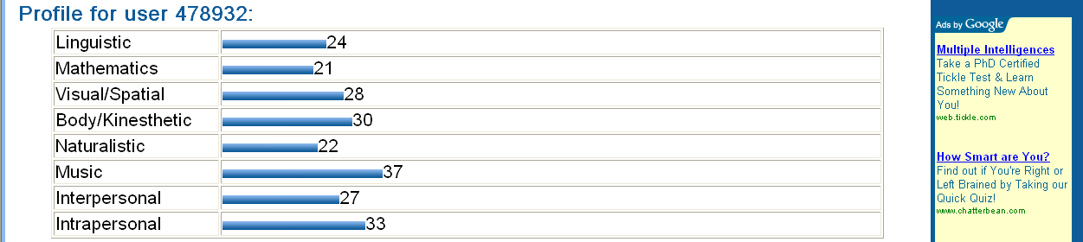

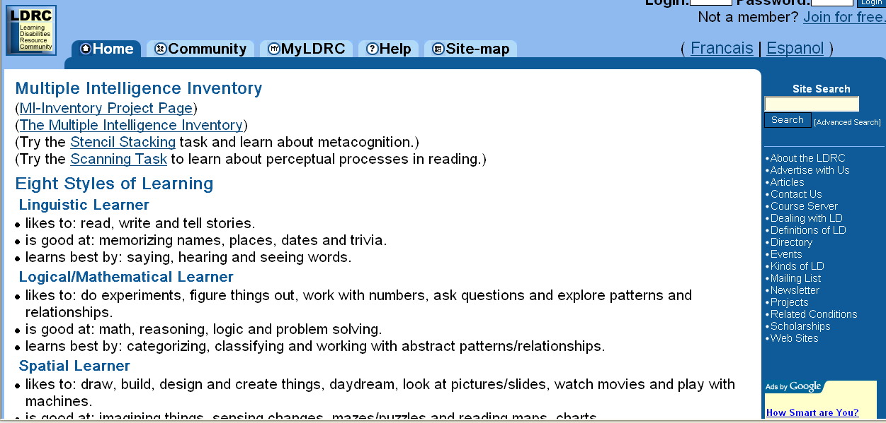

Literacy Works: Respond to the statements and submit them for scoring.

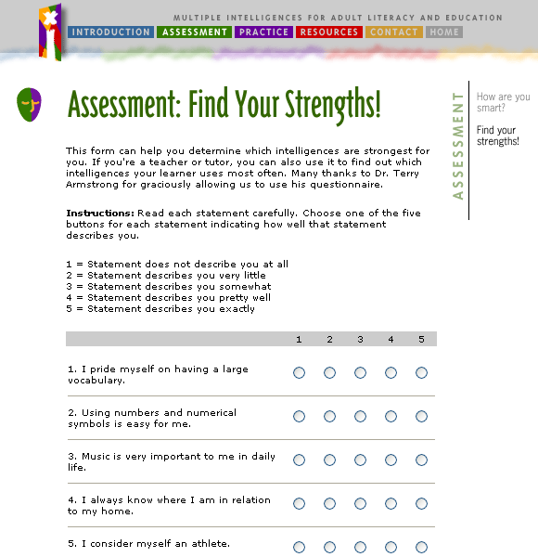

Read your scores, then read more detailed information.



