How to Read (and REMEMBER!) AP World

Managing Reading Area and Time

- Create an effective reading area (lots of workspace, minimize distractions)
  - NOT on your bed
PHONE IN ANOTHER ROOM!!
- Small portions of time
  - Use a timer
  - Start by reading for 5 to 10 minutes (maybe use a kitchen timer?)
  - Gradually increase each session
- “Vacation” list (not a doodle sheet)
  - Sheet of paper next to you
  - Random thoughts?--write them down on paper
  - At end of reading, take quick “vacation”

Pre-Reading
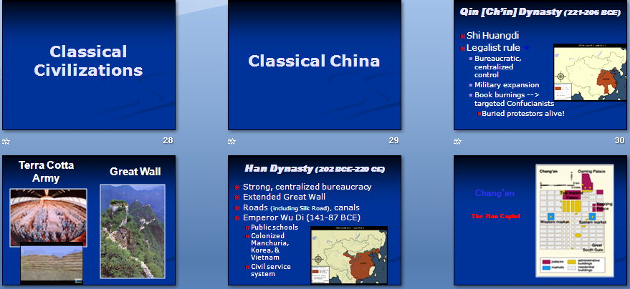

1. Skim Unit Intro PowerPoint
  - Quick quiz after you skim them
(This is VERY VERY important!)

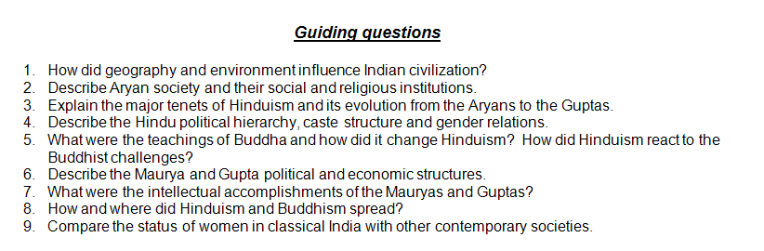
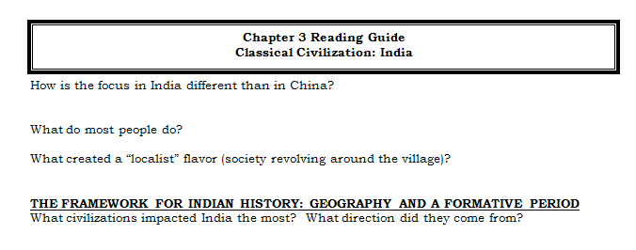

2. Skim Chapter Guiding questions
and Reading Guide
  - Quick quiz after you skim them
(This is VERY VERY important!)

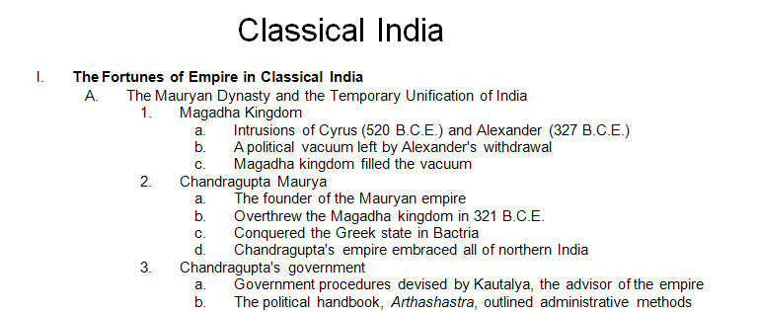
Read Outline(s)
  - Quick quiz after you read them
(This is VERY VERY important!)
  - You do NOT have to memorize them

4. Look over ID’s
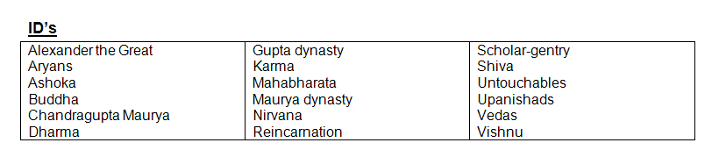
  - Write them on Post-It’s to use when
reading
  - Quick quiz after you write them

5. Skim topic outline at beginning of chapter
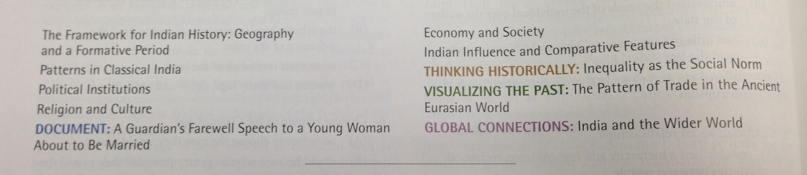
  - Move index finger down middle of reading
  - Quick quiz after you skim it
(This is VERY VERY important!)
Reading

- Skim blue sections in chapter
  - Move index finger, pen, or pencil down middle of reading
    - Notice topic headings
    - Look at visuals
    - Skim words
    - Look for & tab (place Post-It’s near) ID’s
  - Quick quiz after you skim each section
(This is VERY VERY important!)

- Speed read text
  - Start by reading a paragraph at a time
    - Eventually read several paragraphs before you stop to take notes
  - Move index finger, pen, pencil, or 3X5 card down middle of reading
    - Follow model of how you pleasure read
      - Push the story along
    - Allow your eyes to look for:
      - Capitalized words
      - Numbers
      - Strong words
    - Do not worry with small words like a, an, etc.
    - Fill in “story” of text using closure
  - Get one or two pieces of information per paragraph
    - Does NOT have to be the “most important”
  - Take notes into GPIRATES charts, guided by Guiding questions and Reading Guide
  - Do timelines and maps
  - Notice change and continuity, and comparisons
  - Quick quiz as you read/take notes
(This is VERY VERY important!)

Before you begin to read each day:
  - Look over previous notes
  - Quick quiz over your notes
(This is VERY VERY important!)

4. After you have read each day:
  - Look over your notes for the day
  - Quick quiz over those notes
(This is VERY VERY important!)

If you follow these steps, you will find
that you will spend LESS time reading
and officially “studying” for tests.

You will also find that when you study for tests
you see your notes as old friends, much easier to remember.

